**Activity Diagram:**

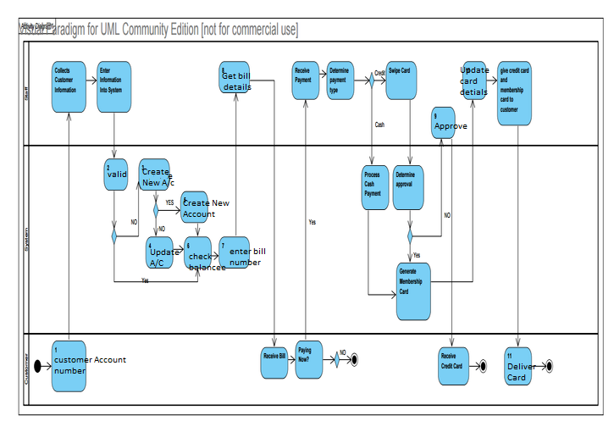

**Use Case Description**

|  |  |  |  |
| --- | --- | --- | --- |
| Use Case Name: Process New Customer | | ID: 1 | Importance Level: H |
| Primary Actor: Staff |  | | |
| Stakeholders and Interests:  Customer – Want to join the health club.  Staff – Assists customer with membership. | | | |
| Brief Description: **Customer joins health club and staff assists with discount rate and billing methods in order to process their membership.** | | | |
| Trigger: **New customer places an order to receive promotional info.** | | | |
| Relationships:  Include:  **Manage Customer**  Extend: | | | |
| Normal Flow of Events:   1. Customer requests membership. 2. **15 Processing documents** 3. **16 Getting desired membership months** 4. System determines the discount rate.   If desired membership length < 6 months,  then discount rate = 0  Else if desired membership length < 12 months  then discount rate = .10  Else discount rate = .15   1. System calculates payment amount. 2. System generates bill. 3. Staff gets bill and gives to customer. 4. Customer presents accepted form of payment (cash or credit card). 5. Staff executes the Process Payment use case. | | | |
| SubFlows: | | | |
| Alternate/Exceptional Flows:  8a. **17 Process existing customer terminates**  8b. Process New Customer terminates. | | | |

|  |  |  |  |
| --- | --- | --- | --- |
| Use Case Name: Process Payment | | ID: 2 | Importance Level: M |
| Primary Actor: Staff |  | | |
| Stakeholders and Interests:  Customer – Person that is paying for new membership.  Staff – Employee receiving payment. | | | |
| Brief Description: **This use case describes how the payment received for membership is processed by staff.** | | | |
| Trigger: **Customer requests for payment** | | | |
| Relationships:  Include: **Staff processes payment from customer**  Extend: **Customer payment method is declined** | | | |
| Normal Flow of Events:   1. Customer presents accepted form of payment to staff.   If payment is with **Cash,** the **Physical Tender** subflow is performed.  If payment is with **Card**, the **Digital Tender** subflow is performed.   1. System generates membership card. 2. Staff executes **Payment Processed** use case. | | | |
| SubFlows:  S-1a. Cash Payment   1. Staff records cash payment. 2. Staff puts cash in cash box and gives customer change if necessary.   S-1b. Credit Card Payment.   1. **27: If entered amount is less than available balance** 2. **28: Process the payment** | | | |
| Alternate/Exceptional Flows:  S-1b-2a. **the customer bills payment to house** | | | |

|  |  |  |  |
| --- | --- | --- | --- |
| Use Case Name: Process Declined Credit Card | | ID: 3 | Importance Level: M |
| Primary Actor: Staff |  | | |
| Stakeholders and Interests:  Customer – Person requesting a new membership.  Staff – Employee working at the health club. | | | |
| Brief Description: **Customers payment via credit card gets declined and staff must process another**  **payment type** | | | |
| Trigger: **Customers payment gets declined** | | | |
| Relationships:  Include:  **Customer attempts to use different type of payment method**  Extend: | | | |
| Normal Flow of Events:   1. Staff notifies customer that credit card was not approved and returns credit card to customer. 2. Staff asks customer for another form of accepted payment. 3. Customer gives staff another form of payment. 4. **33 Customer enters correct details in the form.** | | | |
| SubFlows: | | | |
| Alternate/Exceptional Flows:  3a. **34 Customer declines process.**  3b. Staff terminates processes. | | | |

|  |  |  |  |
| --- | --- | --- | --- |
| Use Case Name: Issue Membership Card | | ID: 4 | Importance Level: M |
| Primary Actor: Staff |  | | |
| Stakeholders and Interests:  Customer – New member receiving membership card.  Staff – Employee issuing membership card. | | | |
| Brief Description: **Staff issues processed gym membership and Customer accepts terms and conditions** | | | |
| Trigger: **Staff issues gym membership** | | | |
| Relationships:  Include:  Extend: | | | |
| Normal Flow of Events:   1. **37 Issued Validity as per customer requires.** 2. **38 Delivered membership cards.** | | | |
| SubFlows: Checking details are valid or not | | | |
| Alternate/Exceptional Flows: Declined issuing Membership card. | | | |